|  |
| --- |
| **BACH KHOA- APTECH COMPUTER EDUCATION** |
| eProject Report |
| Bouqueti Shop (Java Florist) |
|  |
| |  |  | | --- | --- | | **<Group 1>** | | | **Group Member** |  | | **Batch** |  | | **Center** |  | | **Semester** | <3> | |
|  |

|  |
| --- |
| - Hanoi, 10/2022 - |

**Contents**

1. Acknowledgements 4

2. Introduction 4

3. Problem Definition 4

3.1. Problem Abstraction 4

3.2. The Current System 4

3.3. The Proposed System 4

3.4. Boundaries of the System 4

3.5. Development Environment 4

4. Requirements and Business Flows 5

4.1. Customer Requirements 5

4.2. Activity Diagram 5

4.3. Use Case Diagram 5

4.4. Use Case Specification (optional) 5

4.5. Other Concerns<Optional> 6

5. Design 7

5.1. System Architecture 7

5.2. Class Diagram 7

5.3. Class Diagram Explanation 7

5.4. Sequence Diagram (Optional) 7

5.5. Collaboration Diagram (Optional) 7

5.6. State Diagram (Optional) 7

5.7. Entity Relationship Diagram 7

5.8. Database Design 7

5.9. Algorithms (optional) 8

5.10. Others (optional) 8

6. System Prototype 9

6. Management and Project Planning 10

6.1. Management Approach 10

6.2. Project Plan 10

6.3. Task Sheet 10

6.4. Meeting Minutes (Optional) 10

7. Checklists 11

7.1. Check List of Validation 11

7.2. Submission Checklist 11

8. Screenshots 11

9. Coding Convention 11

10. User Guide 12

11. Other Concerns<Optional> 13

Appendix 14

Glossary [Optional] 14

References [Optional] 14

Others<Optional> 14

# Acknowledgements

# Introduction

This document provides a detailed description of the system requirements .Includes business processes and data exchanged in the system . The functions, business processes described in the document are the scope of the software.

# Problem Definition

## Problem Abstraction

One way of communicating wishes are by sending flowers. So our client “java florist” wants to develop a website which would help people to communicate wishes by sending flower bouquet on special occasion. Java Florist offers professionally designed flower arrangements for all occasions like Birthday, wedding, new baby, thank you, fathers day, mothers day etc. The services that will be offered by java florist include delivery of bouquets in Mumbai and surrounding areas, and can even handle flower delivery nationwide through there network of trusted florists.

## The Current System

The application will have a web page which have links or option home, My account, about flowers, view cart, ,florist registration etc.

## The Proposed System

We propose to use a web application system for buy bouqueties and send message.

## Boundaries of the System

We design section with 2 module:

**Admin:** Admin login should able to update and delete the bouquets available, there price etc.

**User:** User can see and navigate the content of the website and also can register their account and choose the bouqueties with message specified. Also they can payment when receive or pay by credit card.

## Development EnvironmentBackend

We program in C# environment, the framework used is ASP.NET MVC with entity framework, the database management system used are Microsoft SQL Server for development environment.

In frontend , we program in HTML, CSS, JS, lib Jquery .

# Requirements and Business Flows

## Customer Requirements

Our client, java Florist wants the following actions to be implemented:

1. The application will have a web page which have links or option home, My account, about flowers, view cart, ,florist registration etc.
2. the home page will also have link for different occasions and when the user clicks on any occasion the bouquets available with that occasion would be displayed with there price.
3. If the user wants to book any bouquets he has to register himself. At a time the user can book more than one bouquets. At the time of booking the bouquets gets attached to cart and the total price will be calculated.
4. The price would be paid through credit card.
5. After paying the money it should also collect the information to whom the bouquet have to be delivered, their name, address, phone no and the message.
6. For messages there would be dropdown list having all the occasion in the list. According to the selected occasion predefined messages will be displayed and the user can choose one of them. Also he can write his own message in the text area provided.
7. The bouquet will be delivered with in the five hour of the booking. The working hour of the florist is morning 9 a.m to evening 9 p.m. If the booking order is within the five hours of working hour the bouquet will be delivered on the same day otherwise it will be delivered on the next day.
8. Admin login should able to update and delete the bouquets available, there price etc.

## Activity Diagram

## Use Case Diagram

## Use Case Specification

## Other Concerns

# Design

## System Architecture

*We use object-oriented architecture and layer architecture for business processing*

## Class Diagram

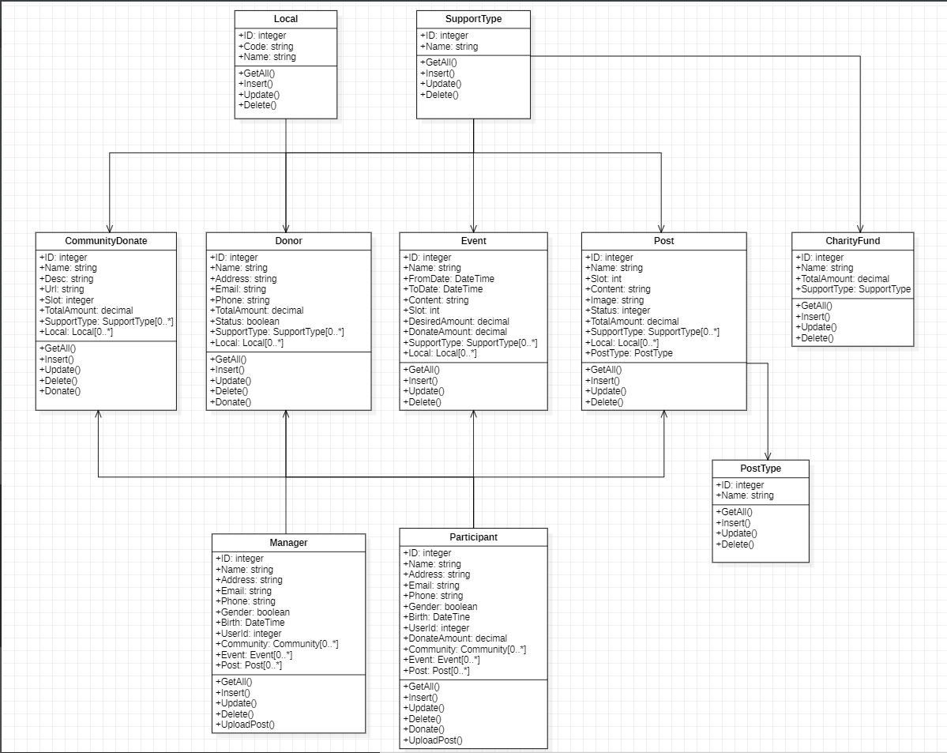

## Class Diagram Explanation

The system has 2 class objects (manager and paticipant) representation for 2 group users accessing into sites.

-Manager is the user with the highest access, controls most of the web pages, contains executable functions that affect other classes such as, manages donor management , content manage...

-Both Manager and paticipant user have to implement the Authentication class before they can login to the system . In front page we don’t need authentication to see content . in admin page , we authorization with specific role to specify what user cand do (role admin have full role with all function)

- Base entity class is a general class that contains information about tracking, operation time, creating or changing data.

## Sequence Diagram

## Collaboration Diagram

## State Diagram

## Entity Relationship Diagram

## Database Design



## Algorithms

## Others

# System Prototype

1. Admin Page

# Management and Project Planning

## Management Approach

## Project Plan

## Task Sheet

## Meeting Minutes (Optional)

# Checklists

## Check List of Validation

*< Put the checklist here; describe how it is used and the resulted checklist>*

## Submission Checklist

*< Put the checklist here; describe how it is used and the resulted checklist>*

# Screenshots

*<Capture some intuitive and main screens of the software and put them here>*

# Coding Convention

*<Provide the coding convention for your team. If you simply want to use the existing code standard(s) such as ‘Java Code Convention’, you can refer to it\them by name or URL>*

# User Guide

*<Provide guidelines for using the system >*

# Other Concerns<Optional>

*<If you have any other information you want to add to this document, place it here. This could include thoughts on the eProject, improvements, etc.>*

# Appendix

## Glossary [Optional]

*<Place all definitions or abbreviation used in this document >*

## References [Optional]

*<Place all referenced materials used in this document >*

## Others<Optional>